|  |  |  |  |  |
| --- | --- | --- | --- | --- |
| DE-ACTIVATING THE LACOE DATA CENTER FIRE ALARM PANEL (FAP | | | | |
|  |  |  |  |  |
| **Originator:** | Cesar Estrada |  | **Effective Date:** | September 26, 2020 |
| **Manager Approval:** | Sender De La Roca |  | **Original Date:** | September 26, 2020 |
|  |  |  | **Revision Date:** | September 26, 2020 |
|  |  |  |  |  |
|  | | | | |
| **Purpose** | | | | |
|  | | | | |
| How to manually De-Activate & Re-Activate the Fire Alarm Panel(FAP) when performing previously approved hot work or sub-floor/overhead maintenance or cleaning that could set off the sensors of the fire system. | | | | |
|  | | | | |
| **Procedure** | | | | |

**Preparatory Step**

1. **Connectivity to EC Building Fire Alarm System**: Prior to beginning any step in de-activating the fire alarm system in the Data Center, LACOE staff must first notify LACOE Security (x6666) to alert Building Fire Alarm monitoring company that the Data Center fire suppression system would be disabled for the duration of the pre-approved task beginning at a pre-determined date and time and estimated time of when the system will be re-activated.

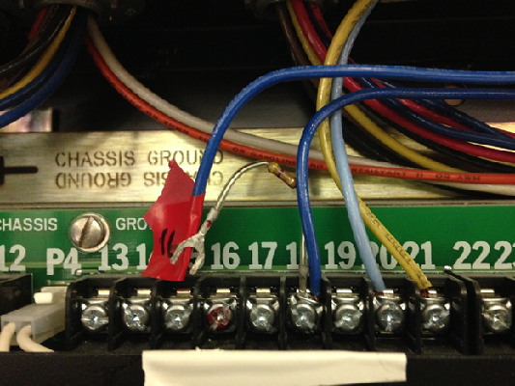**SYSTEM3 PANEL**

1. Disconnected wire #16 on the System3 Panel (Blue). This is the wire that sends a signal to EC building fire monitoring system.
2. 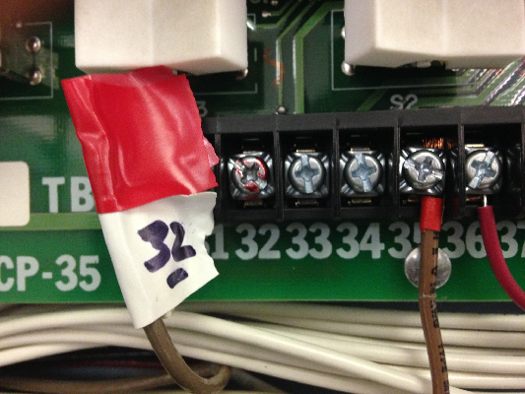Disconnected wire #32 from the System 3 Panel. This is the wire that sends a signal to the bell.

**RM-30U Cards Solenoid Control**

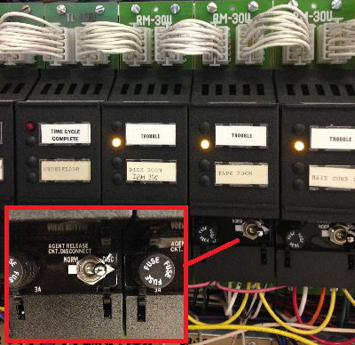

1. Flip from NORM to DISC the switch on each of the five RM-30U cards. Switch handles will lean towards RIGHT.
2. 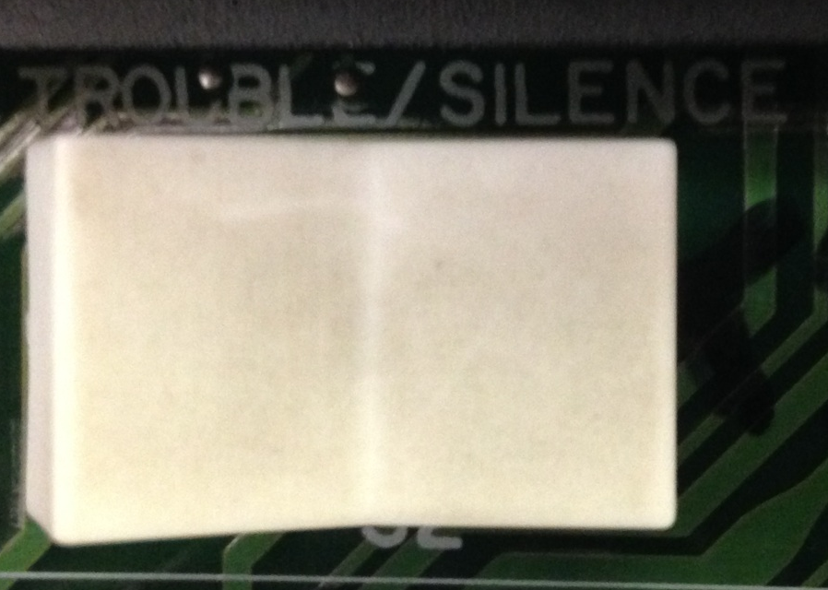 Step 4 above causes trouble alarm to go off. To turn off alarm, flip **TROUBLE ALARM** switch from **TROUBLE to SILENCE**.

**SM-30 HORN & HALON CIRCUITS**

1. 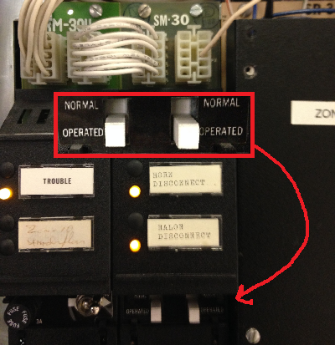Slide down the switches on the SM-30 card labeled HORN DISCONNECT and HALON DISCONNECT. These switches disengage the circuits for the horn (alarm) and the Halon.

**EPSMS PANEL**

1. 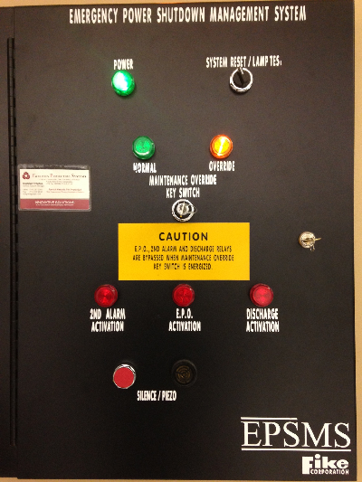Turn the switched key from **NORMAL** to **OVERRIDE** on the Emergency Power Shutdown management System (EPSMS) panel.

(NOTE: when switching key back to NORMAL if SILENCE/PIEZO alarm goes off, twist SYSTEM/RESET/LAMP TES. button to reset.

**HALON TANKS**

1. 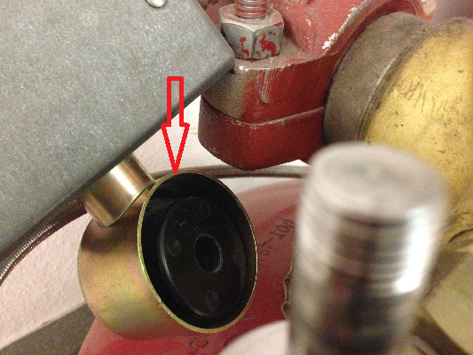Removed actuator/selenoid from halon tanks and water sprinkler main valve

NOTE: The HALON tanks and water valve are spread out in various locations as noted below :

1. Room 160-6 (OA Room) 1 solenoid for two Halon tanks

2. Room 164 (Server Room) 1 solenoid for two Halon tanks

3. Room 164 (Server Room, fire sprinkler closet) 1 solenoid for water sprinkler tank

4. Room 171 (Mechanical Room) 1 solenoid for three Halon tanks (NOTE: Opening mechanical room sends an alarm to LACOE Security. Please contact LACOE Security and have them open this room).

5. Room 154 (Computer Operations Stock Room) 1 solenoid for small Halon tank, 1 solenoid for two larger Halon tanks.

**End of Procedure**

1. At this point, hot work or any task previously approved requiring deactivation of the alarm system can now proceed.

**RE-ACTIVATING THE LACOE DATA CENTER**

**FIRE ALARM PANEL (FAP)**

**Preparatory Step**

Before attempting to re-activate the fire alarm panel, **check ALL the sensors** if any are activated or detect an abnormal situation i.e. excessive dust, smoke, loose wiring, etc.



If staff are unable to resolve the abnormal condition detected by the sensors**, do not proceed** with re-activating the alarm panel and call the emergency contact phone numbers.

**RM30U – Solenoid Control Cards**

1. 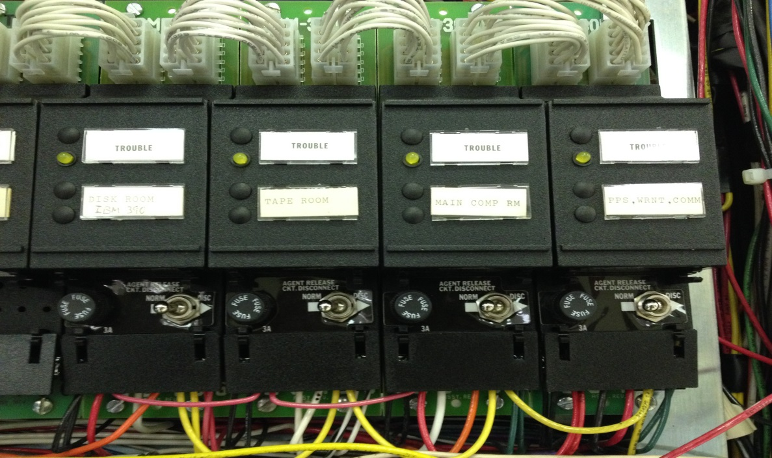 Flip from DISC to NORM the switch on each of the (5) RM-30U cards. NOTE: the switch handles will lean towards **LEFT.**

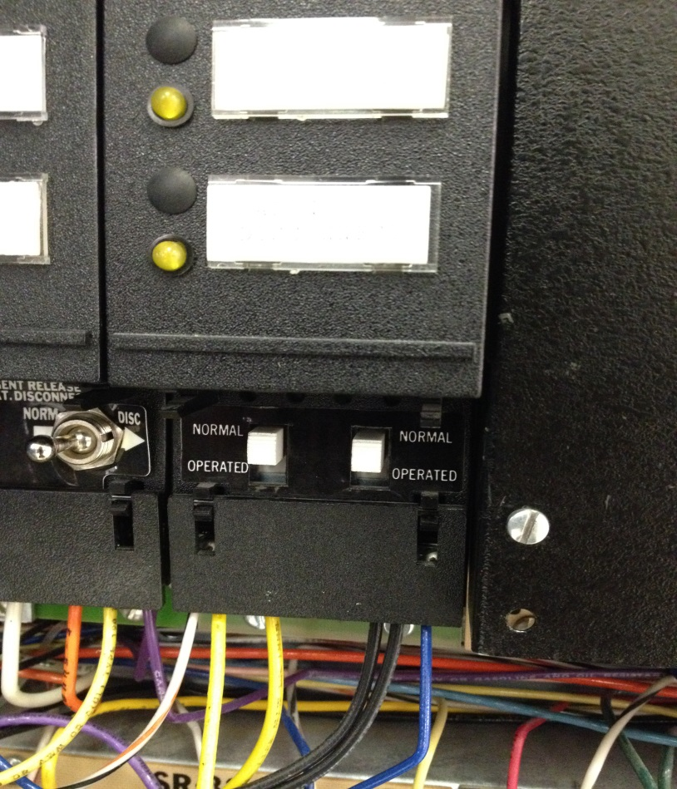**SM30 – Horn and Halon Circuits**

1. Slide **UP** from OPERATED to NORMAL on both switches on SM-30 card.

**SYSTEM 3 PANEL**

1. 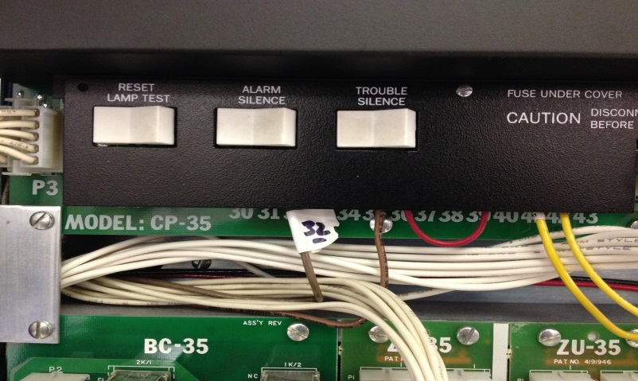 Re-connect wire #32. This is the wire that sends a signal to the bell. Flip TROUBLE ALARM switch from **SILENCE** to **TROUBLE**.
2. 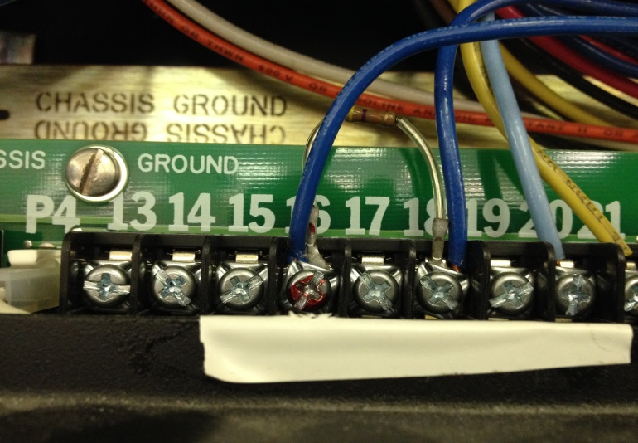 Re-connect wire #16. This is the wire that sends a signal to Building Fire Alarm Company.

**NOTE:** this includes a short lead from a resistor from pin 18.

**HALON TANKS**

1. Reconnect actuator/solenoid back on to Halon tanks and water sprinkler main valve
   1. 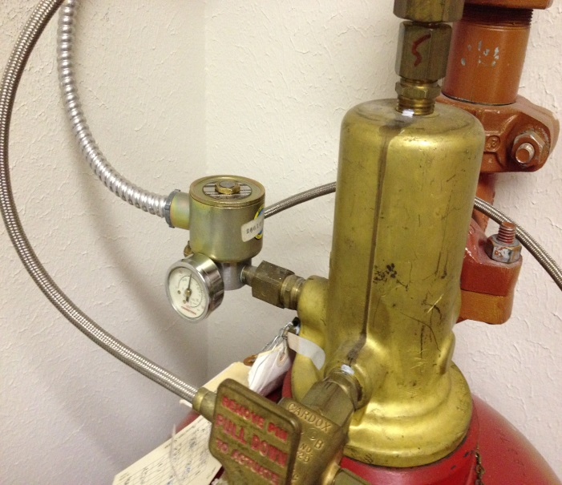Room 160-6 (OA Room) 1 solenoid for two Halon tanks

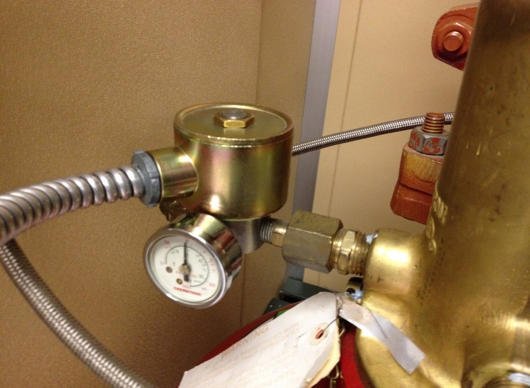5.2 Room 164 (Server Room) 1 solenoid for two Halon tanks

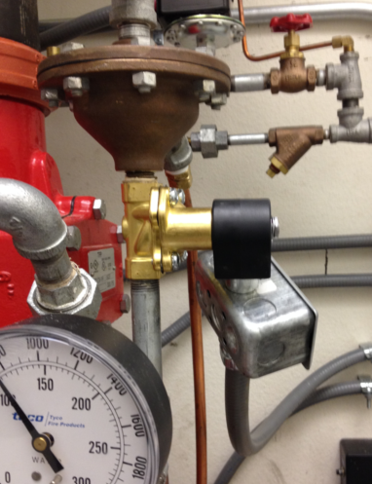5.3 Room 164 (Server Room, fire sprinkler closet) 1 solenoid for water sprinkler tank

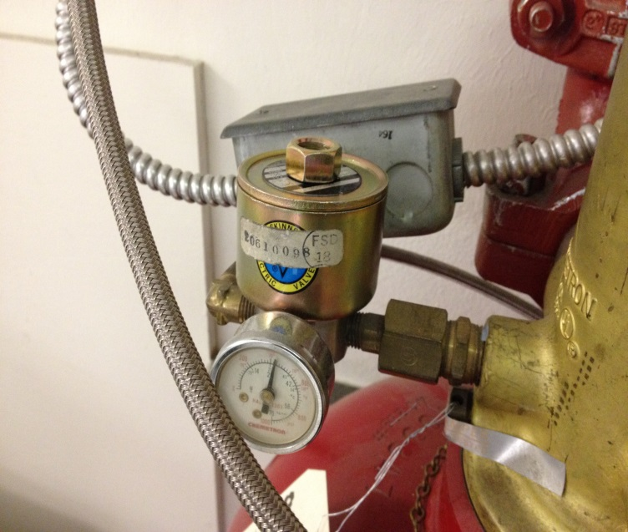5.4 Room 171 (Mechanical Room) 1 solenoid for three Halon tanks (NOTE: Opening mechanical room sends an alarm to LACOE Security. Please contact LACOE Security and have them open this room).

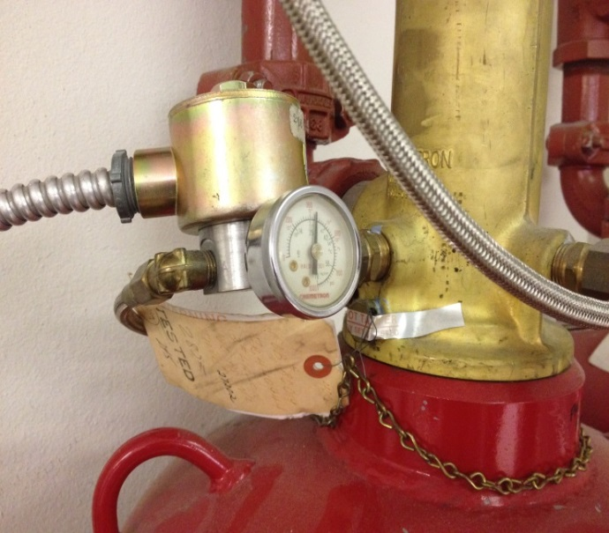

5.5 Room 154 (Computer Operations Storage Area) 1 solenoid for small Halon tank, 1 solenoid for two larger Halon tanks.

**EPSMS PANEL**

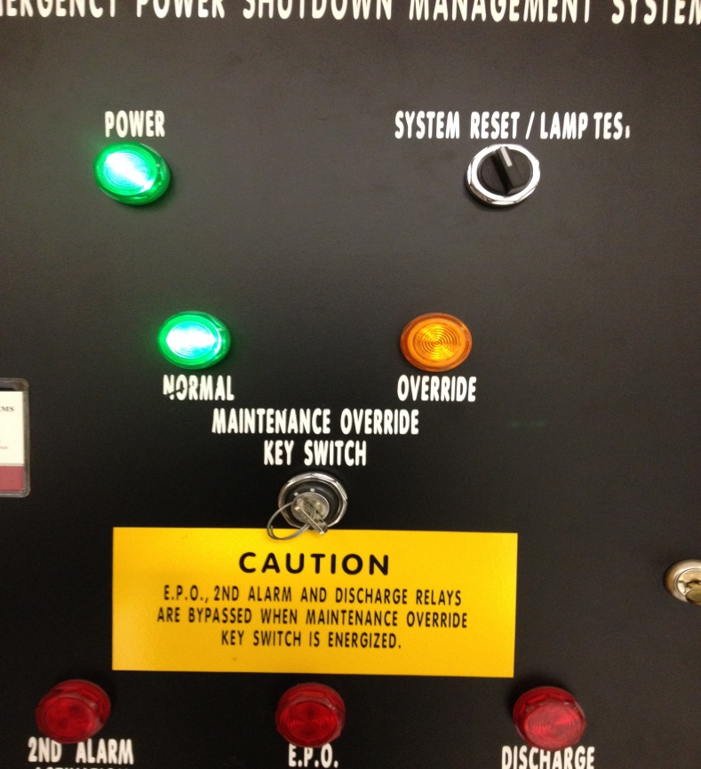

1. Switched key from OVERRIDE to NORMAL.

**NOTE:** SILENCE/PIEZO alarm may go off, then twist SYSTEM/RESET/LAMP TEST button to reset alarm.

**EC BUILDING FIRE ALARM**

1. Contact LACOE Security to notify to contact building fire monitoring company that LACOE Data Center fire alarm system has been re-activated.

**Resetting the Alarm Panel**

**After An Abort on Discharging the Halon**

**Halon Abort Button Still Pressed Down**

**Resetting the Alarm Panel**

The alarm panel can be **reset** by pressing the toggle switch marked **RESET/LAMP TEST** on the main board as below:

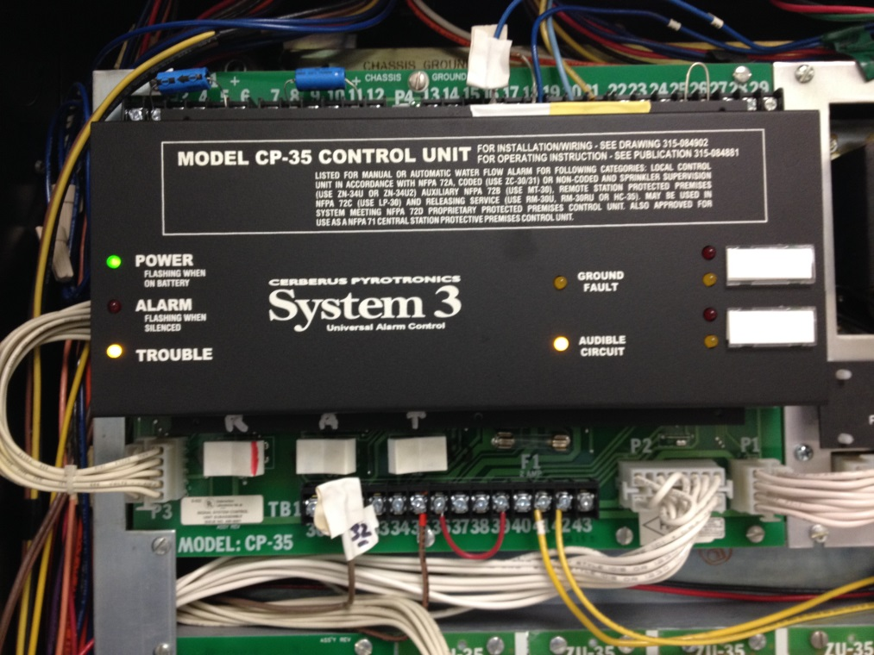

The Halon Abort **must remain depressed** until the reset procedure is complete.

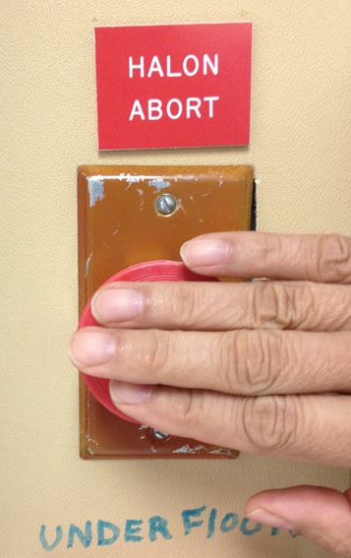

Once the operator confirms that there are no illuminated zones (no lights on any detector) as below:

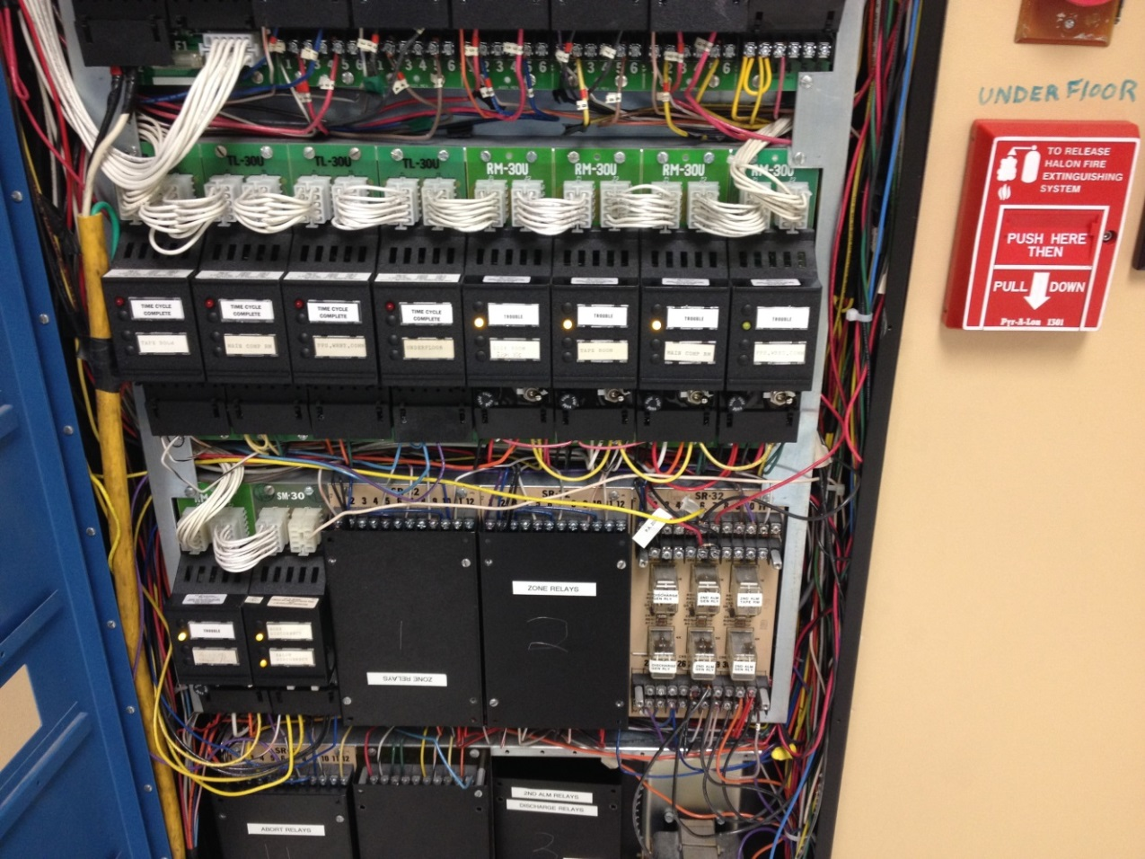

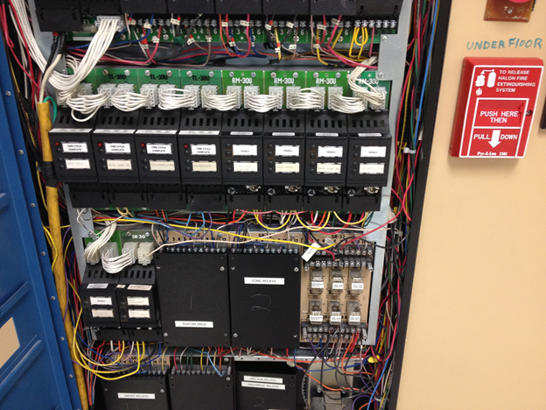

The Halon Abort button can now be released after confirming no lights are illuminated on the panel.

